Title: The Influence of Energy Drinks on Health

I have been a moderate energy drink consumer for a few decades now. I first picked up the habit in 2001 during my first deployment in the Army. Due to long duty hours and short rest periods, most service members turn to energy drinks for a boost. It is not just the military that is consuming caffeine for energy. “A bevy of beverages on the market today can give you a quick caffeine fix. Coffee, of course, is the No. 1 pick-me-up for people in the U.S., with an estimated 154 million adults, or 75% of the population, reaching for their daily cup of joe. (Cleveland, 2024)”

I found that coffee was the main energy source but had limitations. It was more of a morning drink and didn't sit well for hot weather. Additionally, getting additives like sugar and cream was challenging due to the high cost of importing goods. During my second deployment, Rip It energy drinks became available and were called "energy fuel at a price you can swallow." They were even provided for free in the dining facility, and we would take them on convoys. Even now, I still drink energy drinks more out of habit than necessity. I've noticed that I still feel tired even after having a cup of coffee and an energy drink.

My research on this topic using Google Trends yielded little, so I also looked for caffeine and youth. I did find Monster Energy drink on Google Trends under Health and Worldwide; it was consistent in frequency. According to Google Trends, the United States is ranked 6th in searches, but that is just for 2024.

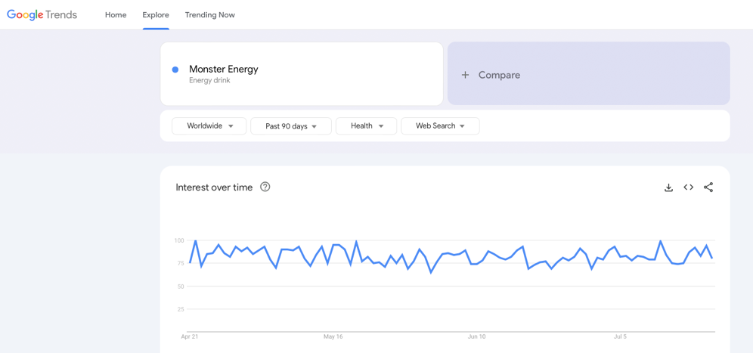

Figure 1: Monster Energy (Google Trends2024)

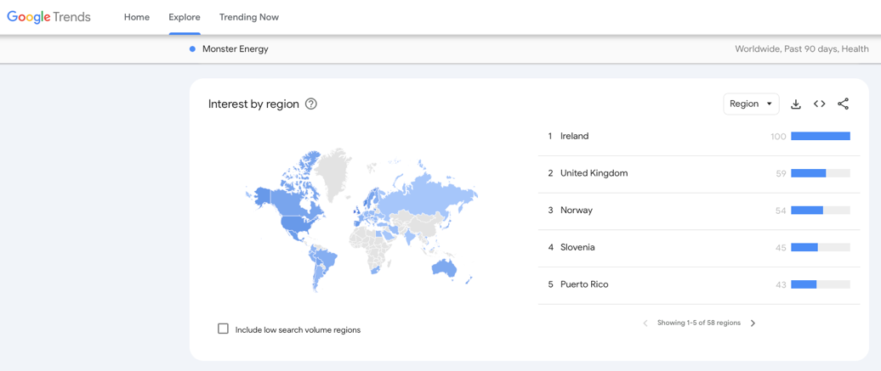

Figure 2: Monster Energy World Rank (Google Trends 2024)

Investigating the effects of energy drinks on our health uncovers a worrying pattern. These beverages have faced intense scrutiny due to their negative impact on health. Reports of severe illnesses and even deaths linked to energy drink consumption have led to legal action against the companies producing these products. The lack of regulations allows these companies to put harmful chemicals into their energy drinks without providing proper warnings.

Beverage companies are marketing these energy drinks as safe, vitamin-fortified beverages that enhance energy levels. These beverages are formulated with a diverse range of ingredients to not only increase energy but also improve mental sharpness and cognitive awareness.

When energy drinks first came out, the targeted consumers of the beverage were athletes. These drinks are marketed to increase energy when exercising or engaging in sports. Young adults are a key target demographic for energy drinks, with males aged 18-34 comprising the most extensive consumer base. About 33 percent of males between 12 and 17 consume energy drinks regularly (DHHS, 2024). These companies strategically market their energy drinks to high school and college students, promoting the idea that the beverages can help maintain alertness and enhance cognitive function. The advertising suggests that consuming these drinks will keep an individual awake and optimize brain performance.

Most energy drinks are carbonated and contain large amounts of caffeine, about the same amount as two cups of coffee. A safe level of caffeine for an adult is 400 mg daily (Cleveland, 2024), equivalent to one 12 oz soda or 4 cups of coffee. ‘“If an adolescent is taking caffeine, the maximum that they should intake per day is 100 milligrams,” Priscilla Mpasi, MD, a pediatrician and Region II chairperson with the National Medical Association, told Verywell’ (Brown, 2022). Verywell lists several of the top brand-name energy drinks and their caffeine content. In order of caffeine levels, monster, Celsius, and Bang contain between 160 and 300 mg in 16 oz cans. Red Bull contains 80 mg of caffeine in an 8.4 oz, and when doubled to match the volume of the brands, it has 160 mg of caffeine (Brown, 2022).

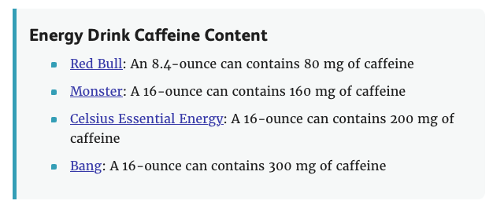
Figure 3: Energy Drink Caffeine Content[JPG] (Brown 2022)

Energy drinks come in various options, catering to individuals looking for sugar-free alternatives and those who prefer the sweetness of sugar-laden versions. These energy drinks contain various vitamins to support overall health and well-being. They also contain other ingredients that increase energy, like vitamin B, guarana, and ginseng. Water or carbonated water is the first element listed in the ingredients, with caffeine and Taurine usually in the top five. “Additional herbs and vitamins such as ginseng, ginkgo biloba, and others do not usually pose a risk” (Garcia, 2023).

Amino acids, found naturally in our bodies, help our bodies to produce proteins. Amino acids are considered organic compounds; nine are essential for human life. Taurine is an amino acid, but it is not one of the necessary organic compounds. However, Taurine does have some health benefits. According to Cleveland Clinic (Cleveland, 2024), Taurine helps to keep the skin and hair hydrated. It assists digestion, thus increasing our metabolism by creating bile salts in the liver. Taurine can help the body control how specific cells receive minerals and levels like calcium. Taurine is known to slow the aging of our brain, improve vision health, and support the immune system. The problem with Taurine as an ingredient is that our body produces the required amount naturally, which is excess as a supplement.

The combination of caffeine and sugar in energy drinks has some associated short-term effects, leading to many emergency room visits (Brown, 2022). People with diabetes are at risk as energy drinks can cause “decreased insulin sensitivity and increased blood sugar.” (Cleveland, 2024). The excessive caffeine content in energy drinks has been linked to heightened heart rates and increased blood pressure, potentially increasing the risk of stroke. Increased caffeine intake is associated with a range of adverse effects, such as anxiety, diarrhea, and nausea and vomiting. “Consuming a large quantity of caffeine over a short time frame can result in physical and mental manifestations of acute caffeine intoxication (Lichvar et al., 2024).”

Studies on energy drinks have shown a link to disrupting natural sleeping patterns and restlessness. Lack of sleep can have detrimental effects on the body, both mental and physical. “Excessive energy drink consumption may disrupt teens’ sleep patterns and may be associated with increased risk-taking behavior. (DHHS, 2024)”

Reversible cerebral vasoconstriction syndrome (RCVS), also known as thunderclap headaches, is “when blood vessels suddenly spasm and constrict (tighten or narrow) in the brain” (Cleveland, 2024). Thunderclap headaches have been characterized by symptoms closely resembling those of migraines, often presenting with sudden and intense pain that can be debilitating. Lack of sleep and restlessness can also contribute to mood swings and short attention spans.

Most energy drinks have water listed as the first ingredient, so some might believe this to mean they provide adequate hydration. However, caffeine can cause water loss or prevent water storage, leading to dehydration. If dehydration lasts for an extended period, it may lead to internal organ damage or even death.

Energy drinks can accelerate heart rates due to their high caffeine and sugar levels. Prolonged consumption over time can have severe implications for the heart, increasing the risk of cardiovascular issues and other serious health concerns.

Many energy drinks are laden with sugar, posing significant risks to dental health and potentially leading to severe implications such as tooth decay and cavities. The excessive sugar content in energy drinks can hinder weight loss efforts, potentially leading to obesity and associated health complications.

No safety regulations currently govern how these drinks are made or who can buy them. “Despite the health risks associated with the overconsumption of caffeine, energy drinks, and similar energy supplements are not regulated any differently by the Food and Drug Administration (FDA) than conventional food or beverages.” (Lichvar et al., 2024).

Going forward, I would research sources regarding hospital emergency room (ER) data associated with caffeine effects on adults compared to adolescents. SAMHSA has some information on ER visits, but the data is a little old.

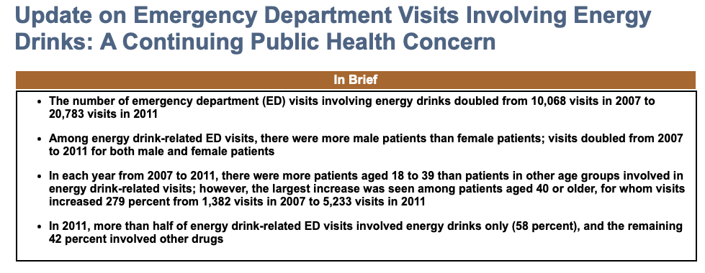

Figure 4: Emergency Room Visits[JPG] (SAMHSA 2013)

I would also want to see young adults' demographics and education levels; are they in high school or college, or are they not? As stated above, younger people are now being targeted with advertisements boosting more energy. College-level students, especially, can never get enough energy to study for exams.

Studies have uncovered many adverse effects of energy drink consumption, outweighing the perceived benefits. It is imperative to introduce warning labels and public service announcements to alert the public, particularly parents, about the potential dangers. Creating regulations like the ones imposed on cigarettes and alcohol and implementing an age restriction through legislation could be crucial to safeguarding public health.

After having done this research, I feel I must find a safer alternative to consuming “energy drinks”. And I will not let my children try them and I will discuss the important of avoiding such beverages. My youngest, a 14-year-old currently only drinks apple juice and water, which is a lot safer.

References:
Google. (n.d.). Monster Energy Drink. Google trends. https://trends.google.com/trends/

U.S. Department of Health and Human Services. (DHHS) (n.d.). (2024, June 29). Energy drinks. National Center for Complementary and Integrative Health. https://www.nccih.nih.gov/health/energy-drinks

Cleveland Clinic. (2024, May 24). Are Energy Drinks Bad for You? Cleveland Clinic health essentials. https://health.clevelandclinic.org/are-energy-drinks-bad-for-you

Brown, S. (2022, July 28). How dangerous are energy drinks? Verywell Health. https://www.verywellhealth.com/energy-drinks-danger-6281116

Garcia, M. C. (2023, August 1). For teens, energy drinks may have harmful side effects. UCLA Health. https://www.uclahealth.org/news/article/teens-energy-drinks-side-effects

Lichvar, A., Pabla, A., Nguyen, N. E., & McDonnell, P. (2024, May 8). Caffeinated energy drinks and supplements: A wake-up call for consumers and healthcare providers: Published in Patient Safety. PATIENT SAFETY. https://patientsafetyj.com/article/116073-caffeinated-energy-drinks-and-supplements-a-wake-up-call-for-consumers-and-healthcare-providers

HARVARD T.H. CHAN SCHOOL OF PUBLIC HEALTH. (2024, May 9). Energy drinks. The Nutrition Source. https://nutritionsource.hsph.harvard.edu/energy-drinks/

SAMHSA. (2013, January 10). Update on emergency department visits involving Energy Drinks: A continuing public health concern. The DAWN Report: Update on Emergency Department Visits Involving Energy Drinks: A Continuing Public Health Concern. https://www.samhsa.gov/data/sites/default/files/DAWN126/DAWN126/sr126-energy-drinks-use.htm

Walsh, K. (2023, October 3). What happens to your body when you drink energy drinks every day? EatingWell. https://www.eatingwell.com/article/8061814/are-energy-drinks-healthy/

